

Royal Bank of Canada

**Churn Analysis Report**



**Prepared By: Data Analysis Unit**

**Ritik Agrawal OM2301**

Copyright © 2023 Omnistique Solutions

# 1. Introduction:

Omnistique is delighted to undertake a comprehensive Churn Analysis project for the Royal Bank of Canada (RBC). This initiative aims to delve into the factors influencing customer churn, providing valuable insights for proactive retention strategies. After extensive discussions with RBC's business team, we have designed a Business Requirement Document (BRD) that outlines the scope, data sources, and steps involved in the analysis.

# 2. Business Requirement Document

## 2.1 Data Dictionary

* **RowNumber:-** corresponds to the record (row) number and has no effect on the output.
* **CustomerId:-** contains random values and has no effect on customer leaving the bank.
* **Surname:-** the surname of a customer has no impact on their decision to leave the bank.
* **CreditScore:-** can have an effect on customer churn, since a customer with a higher credit score is less likely to leave the bank.

**Credit score:**

* Excellent: 800–850
* Very Good: 740–799
* Good: 670–739
* Fair: 580–669
* Poor: 300–579
* **Geography:-** a customer’s location can affect their decision to leave the bank.
* **Gender:-** it’s interesting to explore whether gender plays a role in a customer leaving the bank.
* **Age:-** this is certainly relevant, since older customers are less likely to leave their bank than younger ones.
* **Tenure:-** refers to the number of years that the customer has been a client of the bank. Normally, older clients are more loyal and less likely to leave a bank.
* **Balance:-** also a very good indicator of customer churn, as people with a higher balance in their accounts are less likely to leave the bank compared to those with lower balances.
* **NumOfProducts:-** refers to the number of products that a customer has purchased through the bank.
* **HasCrCard:-** denotes whether or not a customer has a credit card. This column is also relevant, since people with a credit card are less likely to leave the bank.
  + - 1 represents **credit card holder**
    - 0 represents **non credit card holder**
* **IsActiveMember:-** active customers are less likely to leave the bank.
  + - 1 represents **Active Member**
    - 0 represents **Inactive Member**
* **Estimated Salary:-** as with balance, people with lower salaries are more likely to leave the bank compared to those with higher salaries.
* **Exited:-** whether or not the customer left the bank.
* 0 represents **Retain**
* 1 represents **Exit**
* **Bank DOJ:-**  date when the Customer associated/joined with the bank.

## 2.2 Data Gathering:

Please use the following data assets to pull the data related to Bank customer and associated details.

* ActiveCustomer
* Bank_Churn
* CreditCard
* CustomerInfo
* ExitCustomer
* Gender
* Geography

## 2.3 Churn Analysis:

Analyse the data and bring out few insights on the customer Churn.

It is advantageous for bank to know what leads a client towards the decision to leave the company.

# 3. Project Flow Model

**1). Data Gathering:**

Extract data from the specified data assets to form the basis for the churn analysis.

**2). Data Cleaning / Data Transformation:**

* Cleanse and preprocess the data to ensure accuracy and consistency.
* Transform data into a suitable format for analysis.

**3). Data Modelling:**

* Develop a robust data model that aligns with the objectives of churn analysis.
* Apply statistical and machine learning techniques to identify churn patterns.

**4). UI (Power View Reports)**:

* Create Power View reports for visualizing key churn metrics and trends.
* Ensure reports are user-friendly and aligned with the BRD requirements.

**5). DAX Functions Enhancement:**

* Implement Data Analysis Expressions (DAX) functions to enhance analytical capabilities.
* Include custom calculations and measures for deeper insights.

**6). RLS (Row-Level Security):**

* Establish Row-Level Security to control data access based on user roles.
* Ensure sensitive information is only accessible to authorized personnel.

**7). Create Workspace and Provide Workspace Access:**

* Set up dedicated workspaces for the project in Power BI.
* Grant access to team members involved in data analysis.

**8). Publish the Report to Workspace:**

* Publish the finalized Power BI report to the designated workspace for collaborative access.

**9). Dashboard / Mobile View => Create an App:**

* Develop interactive dashboards consolidating key churn insights.
* Create a mobile-friendly view for on-the-go access.

**10). Gateway (One-Time Step):**

* Install and configure a gateway for secure data connectivity.

**11). Schedule a Refresh:**

* Implement scheduled data refresh for up-to-date reports.

**12). Add Roles to Security:**

* Assign specific roles to team members based on responsibilities.

**13). Subscribe:**

* Set up subscription services for notifying stakeholders of updates.

**14). Manage Alerts:**

* Implement alerts to notify relevant personnel of critical churn metrics.

**15). Share the Report:**

* Facilitate seamless sharing of churn analysis reports within the organization.

# 4. Making Report:-

Using above project flow model we will prepare churn analysis report for client.

## 4.1 Data Gathering:-

## The company has provided the dataset in various formats, including Excel and CSV files. A preliminary glance at the dataset reveals its diverse structure and content. This varied compilation of data forms the foundation for our analytical endeavors and emphasizes the need for robust data handling techniques. The inherent variability within the dataset necessitates a meticulous approach to ensure comprehensive insights are derived through systematic analysis. Our team is poised to apply industry-leading methodologies to seamlessly integrate, clean, and transform this dataset, paving the way for an insightful and actionable analytical process.

Glance of dataset which we are provided with.

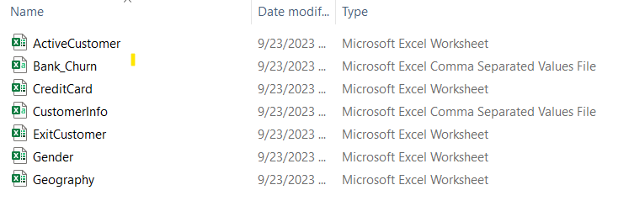

Bank_churn is main business table ie. Fact Table and rest are Dimension table.

**Dataset Link:-** [RBC_Churn_Analysis](https://drive.google.com/drive/folders/1tMD-6K00i8pyBX12KC4RMIiIoG1ETxj0?usp=sharing)

Importing data in Power BI desktop through Get Data >Folder

Now we get Data linked through our Power BI Desktop.

## 4.2 Data Cleaning/Transformation

For transformation of data , we use Power BI Query Editor, in which we remove some columns from data like column name “Row No” is deleted, and do some minimal cleaning operations like removing some null values so that we get our data cleaned.

Lets have a look at our Cleaned data;

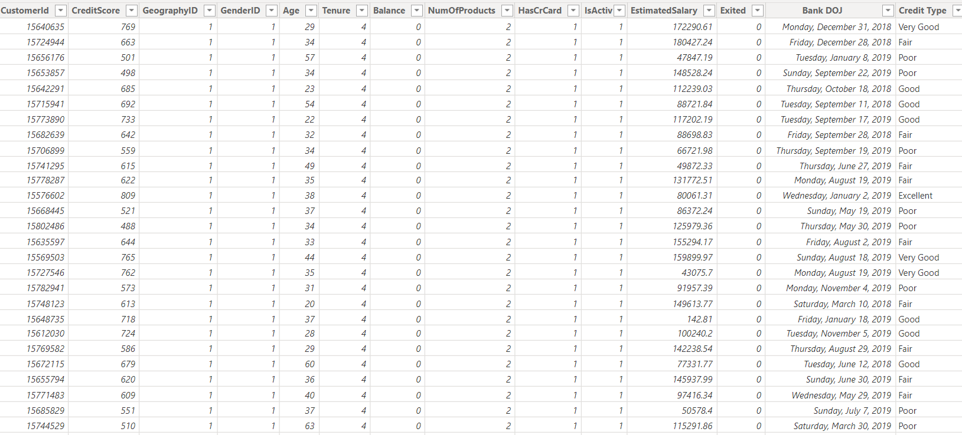

Size of dataset : 10,000 * 13

Adding Date Master Table to access year ,month,day directly,

Write M-Code to get Date Master Table , by firstly click on new table option then write

Following M-Code to get Data column in Date Master Table.



After getting column with name date ,extract year, month, month_name by using new column option and writing these following code-







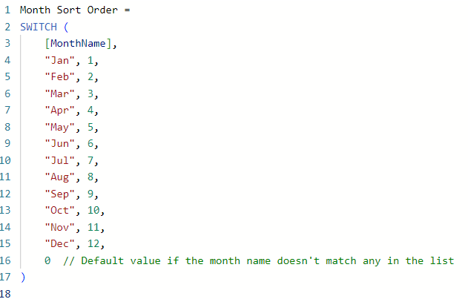

## 4.3 Data Modelling

## We firstly remove the relationships given by software itself and and add 1 to many relationship.

We relate lookup tables containing primary key which is to be mapped with foreign key of fact table.

Data Schema here we got are **Star Schema.**

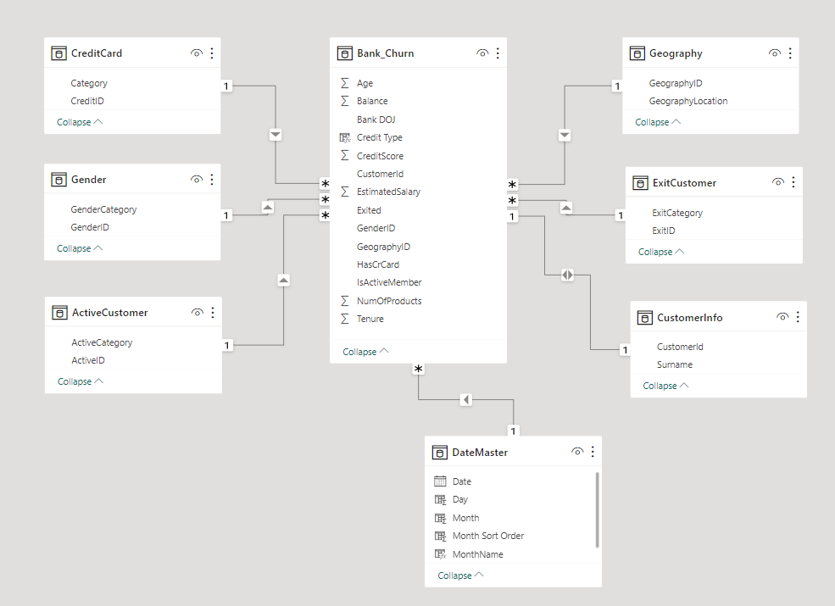

**Data Modelling**

Analysing that Customer Info and Bank_churn have 1 to 1 relationship and rest have 1 to many relationship.

## 4.4 UI/Power BI Reports

After completing data cleaning and data modeling, the subsequent phase involves report building. As a preliminary step, we establish a calculation table wherein all DAX (Data Analysis Expressions) measures are meticulously curated. This approach facilitates the seamless presentation of key performance indicators (KPIs) in our reports.

## 4.5 Dax Measure

Creating DAX measures in Calculation table.

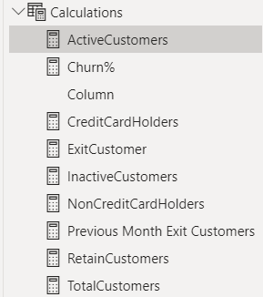

**Active Customers:-**



**Total Customers:-**



**Inactive Customers:-**



**Credit Card Holders:-**



**Non Credit Card Holders:-**



**Retain Customers:-**



**Exit Customers:-**



**Previous Month Exit Customers:-**



**Churn%**

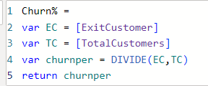

Use format as percentage for Churn %.

After creating DAX Measures we will start report making where we first put title then add slicers- year, monthname ,active category, exit category,gender category.

Based on credit score we have to give them answer in credit type format so creating a column of Credit type with following code according to business requirement document.

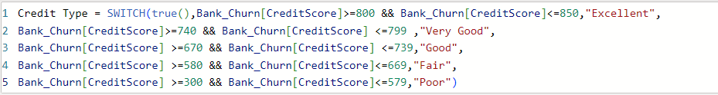

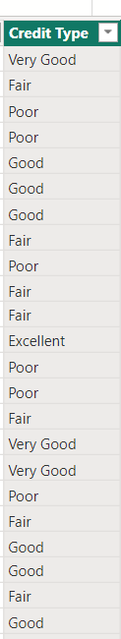

After this we create visuals

***Total Customers Vs Year:-***

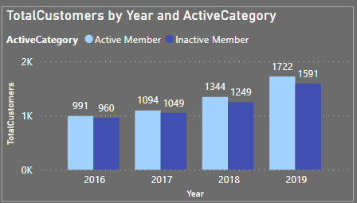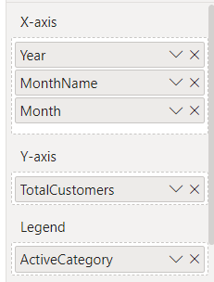

**Visual: Total Customers Vs Year and Active Category**

***Exit Customer and Previous Month Exit Customers Vs MonthName:-***

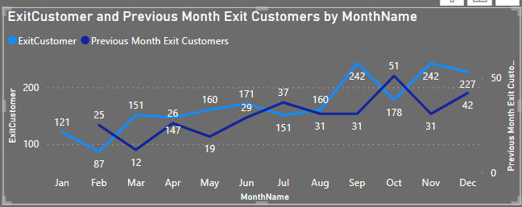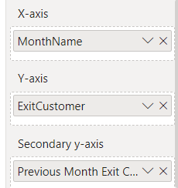

**Visual: Exit Customer and Previous Month Exit Customers Vs MonthName**

***Exit Customer Vs Credit Type:-***

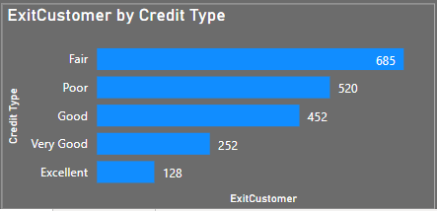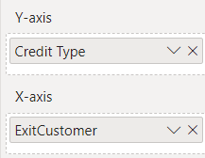

**Visual:Exit Customer Vs Credit Type**

***Exit Customer Vs Gender Category:-***

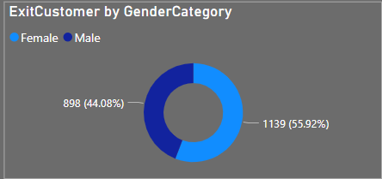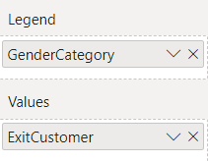

**Visual: Exit Customer Vs Gender Category**

***Exit Customer By Category:-***

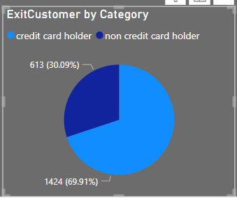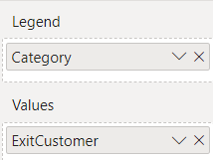

**Visual:Exit Customer By Category**

***Total Customers Vs Geography Location:-***

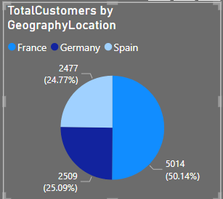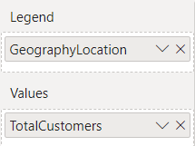

**Visual: Total Customers Vs Geography Location**

As we have not enough space to present data in single page so we use bookmarks and show these bookmarks

**Adding Bookmarks**:- Open View tab > Bookmarks>Add Bookmarks >Rename it Accordingly > Select selection (view tab )>now hide any one one visual you not want to see> Got to bookmark >then update through 3 dots

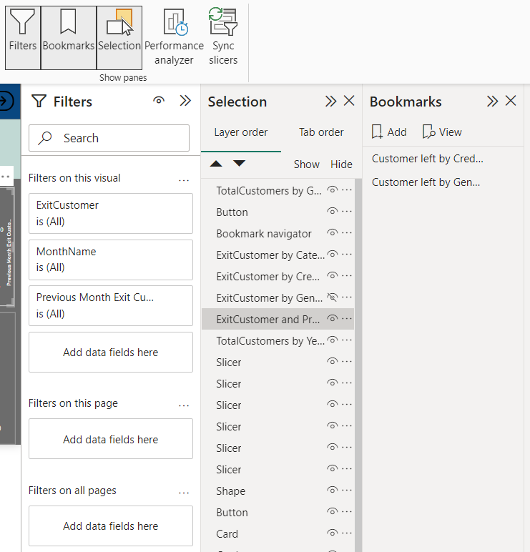

Adding Bookmarks

For Bookmark navigation , we will use buttons, Go to Insert>Buttons>Navigator>Bookmarks Navigator .

Again adding some more visuals on another page name it as Churn%

***Year and Month Wise Churn% :-***

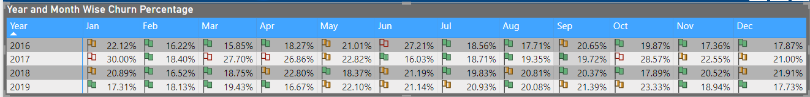

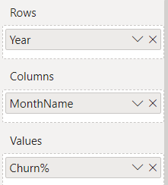

**Visual: Year and Month Wise Churn%**

***Total Churn% :-***

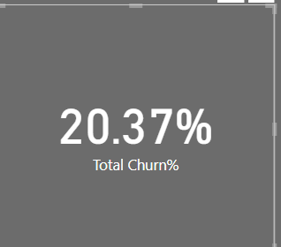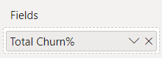

**Visual: Total Churn%**

***Total Customers Vs Age:-***

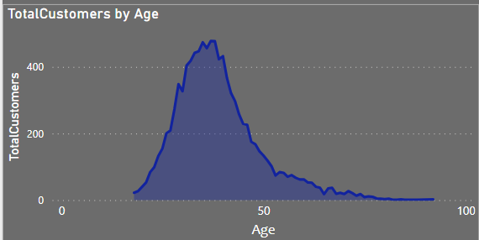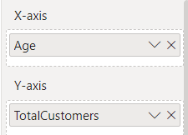

**Visual: Total Customers Vs Age**

***Exit Customer vs NumOf Products***

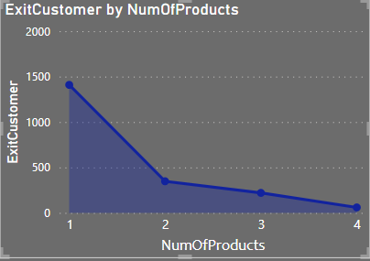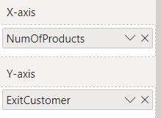

**Visual: Exit Customer Vs NumOfProducts**

***Total Customers Vs Tenure***

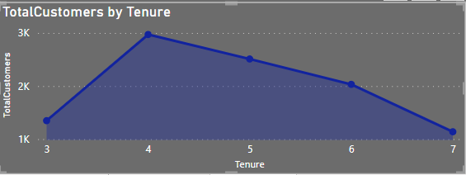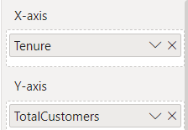

**Visual: Total Customers Vs Tenure**

***CreditCardHolders Vs NumOfProducts***

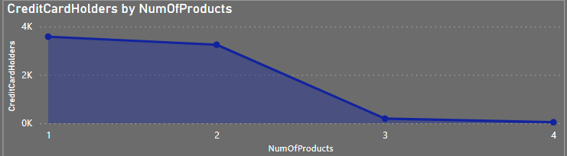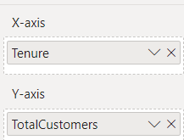

**Visual: CreditCard Holders Vs NumOfProducts**

Adjusted for Mobile view also

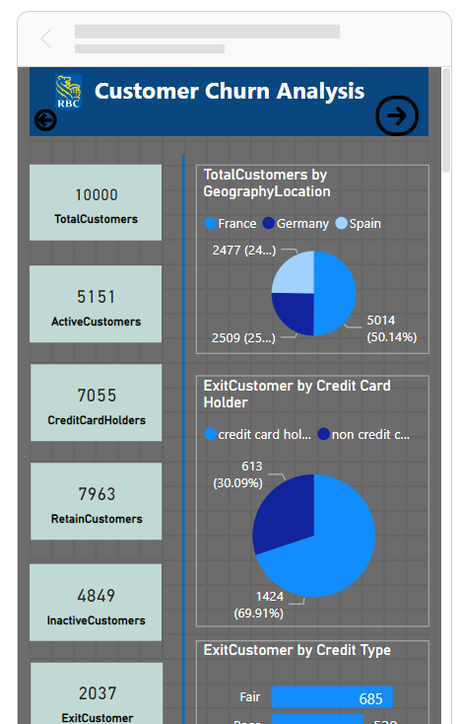

Mobile View

Use button for navigation from Home Page to Churn % and back button also. So It enables to do page change while we upload it on service then export as power point as there we no tabs where we click like Power Bi Desktop.

## 4.6 Row Level Security

To facilitate regional analysis for various head offices situated in different countries, we implement row-level security measures. This ensures that each specific head office has access only to data pertinent to its respective region.

Navigate to the "Modelling" tab, select "Manage Roles," and proceed to create roles based on geographical locations such as France, Germany, and Spain.

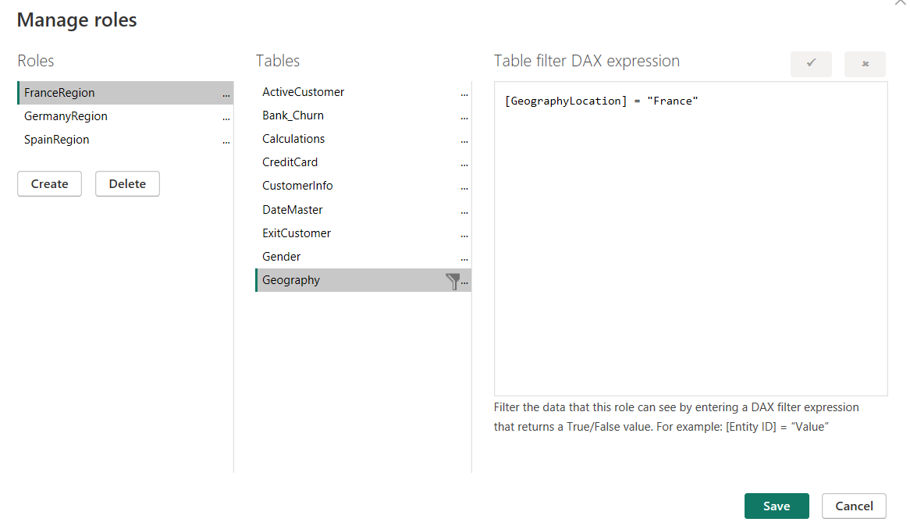

To access the role-specific view, utilize the "View As" option located to the right of the "Manage Role" section.

## 4.7 Creating Workspace and Provide workspace Access:-

Access Power BI online, open the workspace, and initiate the creation of a new workspace named "Royal Bank of Canada Churn Analysis."

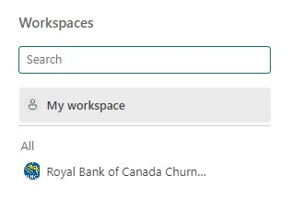

Create Workspace

Utilize the "Manage Access" feature within the workspace to grant permissions to the organization, facilitating both sharing and contributing purposes.

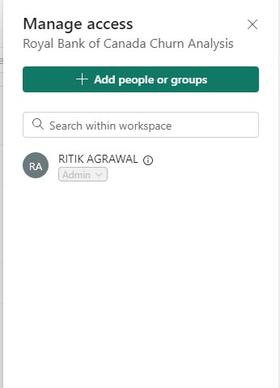

Manage Access

Assign access levels as needed, distinguishing between roles such as Admin, Member, and Viewer, based on specific requirements within the workspace.

For the purpose of Row-Level Security (RLS), users should be granted Viewer access only, ensuring appropriate restrictions and data control.

To implement Row-Level Security (RLS), navigate to the "Churn Analysis Dataset," right-click, and select the "Security" option. Within this section, you can add security measures according to specific roles and their corresponding identifiers.

## 4.8 Publishing the report to workspace

Subsequently, employ the "Publish" option in Power BI Desktop. Sign in with your organizational account and proceed to publish the content into the designated workspace named "Royal Bank of Canada Churn Analysis."

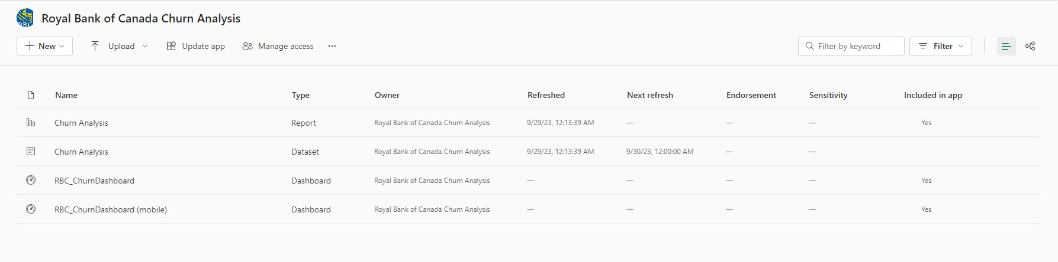

Workspace After publishing Report

## 4.9 Dashboard /Mobile view => Create an App

Develop a dashboard and optimize its mobile view to enhance user experience and facilitate direct presentations with a focus on providing a streamlined interface without extensive interactive features.

In Power BI online, pin the visualizations or insights from the "Churn Analysis" report. After pinning, select "Add to Dashboard," and subsequently, create a new dashboard to organize and present the pinned elements effectively.



Workspace after creating Dashboard and mobile view Dashboard

Proceed to create an app for the final product to facilitate end delivery. This will generate a link associated with the app, allowing for seamless sharing with any intended audience.

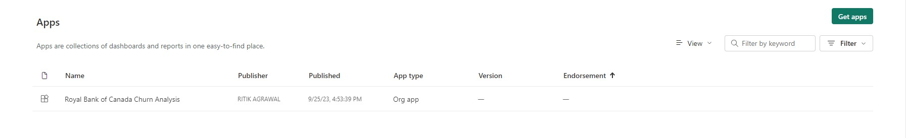

Create App from Workspace

The visual representation of the app will showcase a user-friendly interface, presenting key insights and visualizations related to the final product. It will be designed for clarity and accessibility, ensuring an intuitive and informative experience for end-users.

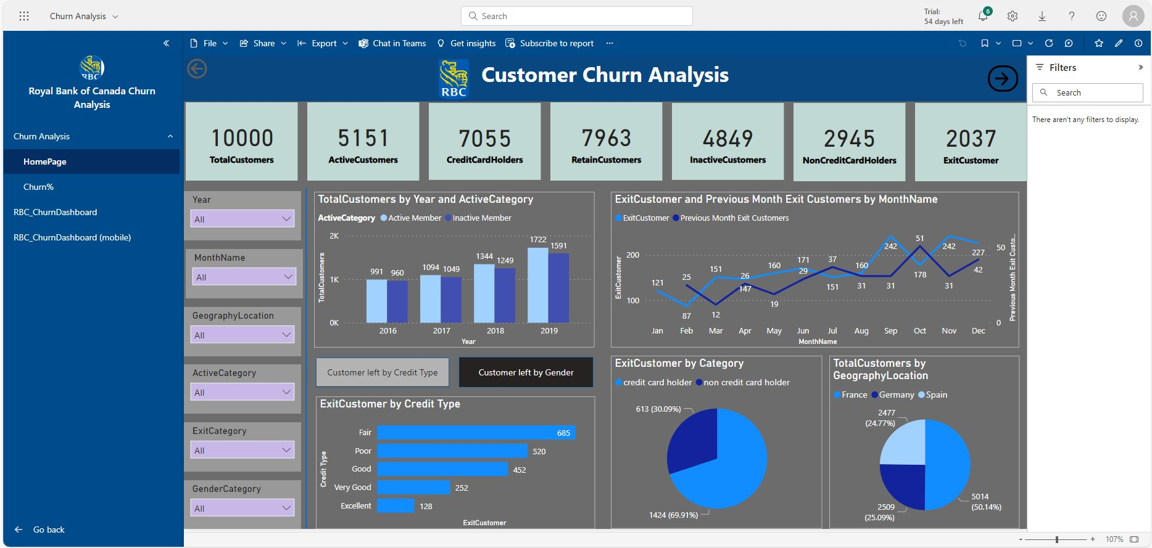

Churn Analysis PowerBI Workspace App(HomePage)

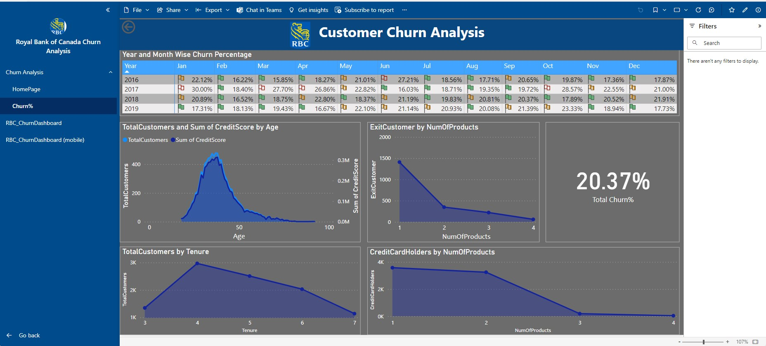

Churn Analysis PowerBI Workspace App(Churn%)

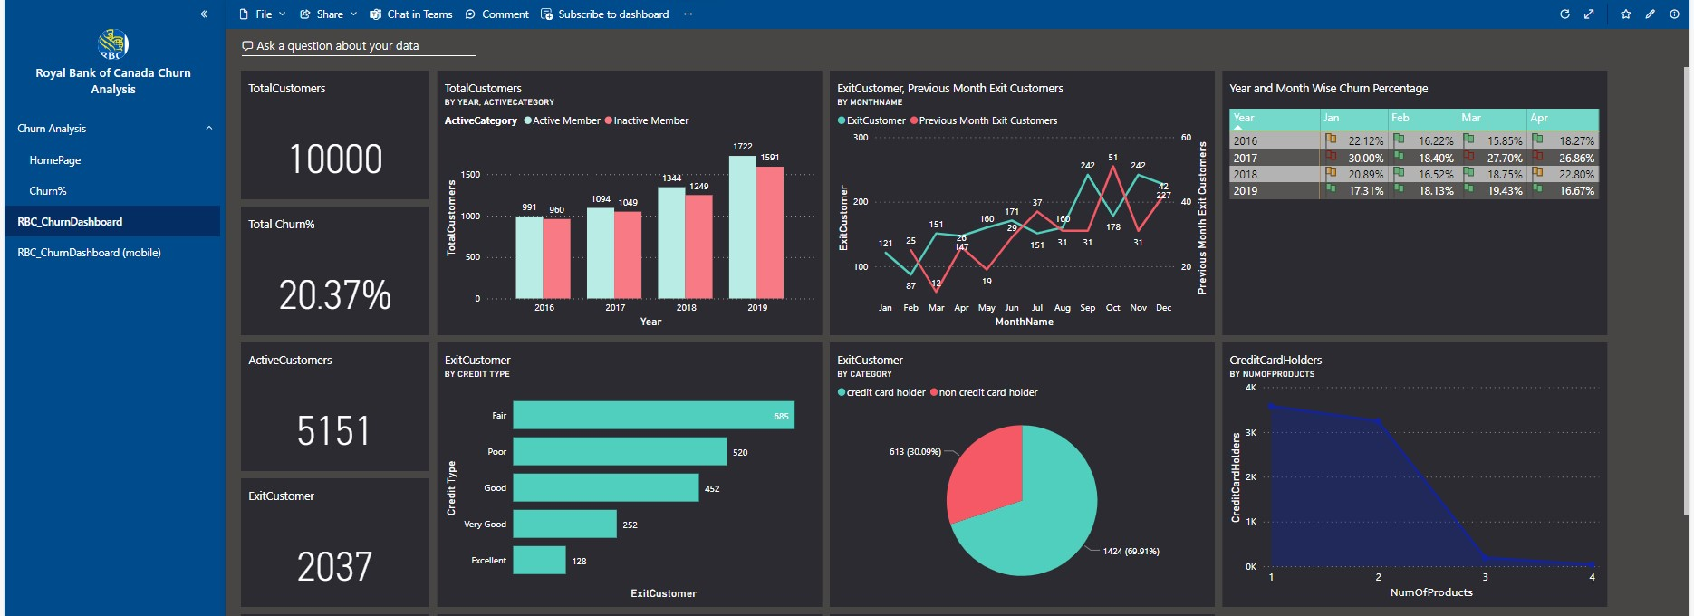

Churn Analysis PowerBI Workspace App(Dashboard)

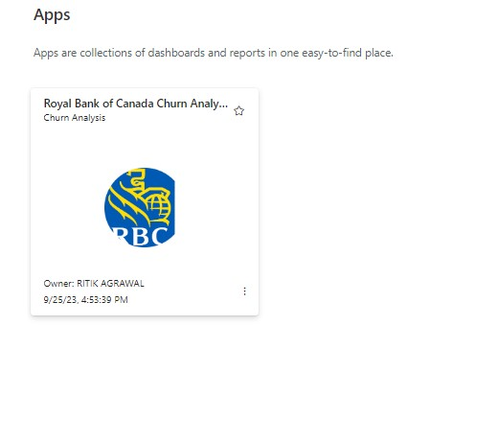

App

The app is now prepared for delivery, featuring a polished and user-friendly interface. The next step is to share or deploy the app, providing stakeholders with access to the valuable insights and data visualizations it contains.

Manage alerts for app for the condition to change like here we manage alerts for Churn>2037.

## 4.10 Gateway Connection

To initiate a scheduled data refresh, the initial step involves establishing a connection between the application and the authentic data source. In our scenario, where the data resides on-premises or locally, it necessitates the download and deployment of the gateway for seamless progress.

Upon downloading the gateway and establishing a connection, let's examine how the workspace view appears in the lineage view.

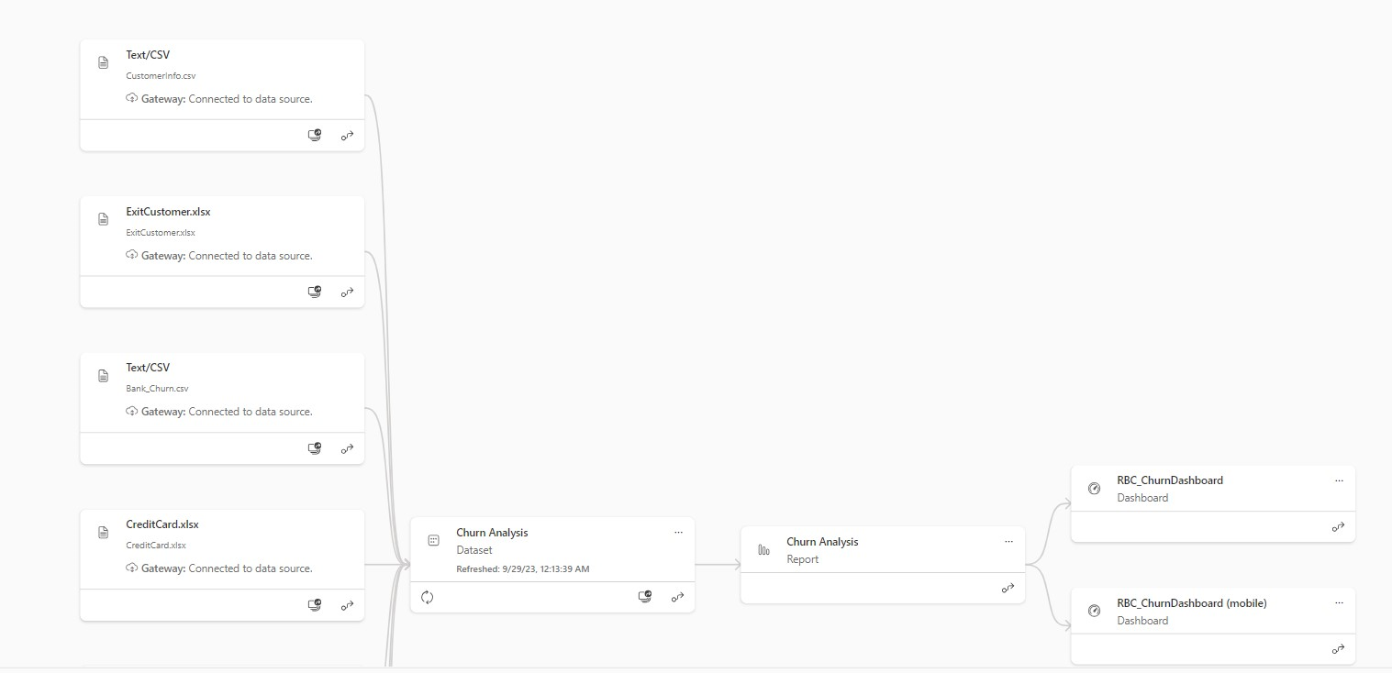

Lineage view after gateway connection

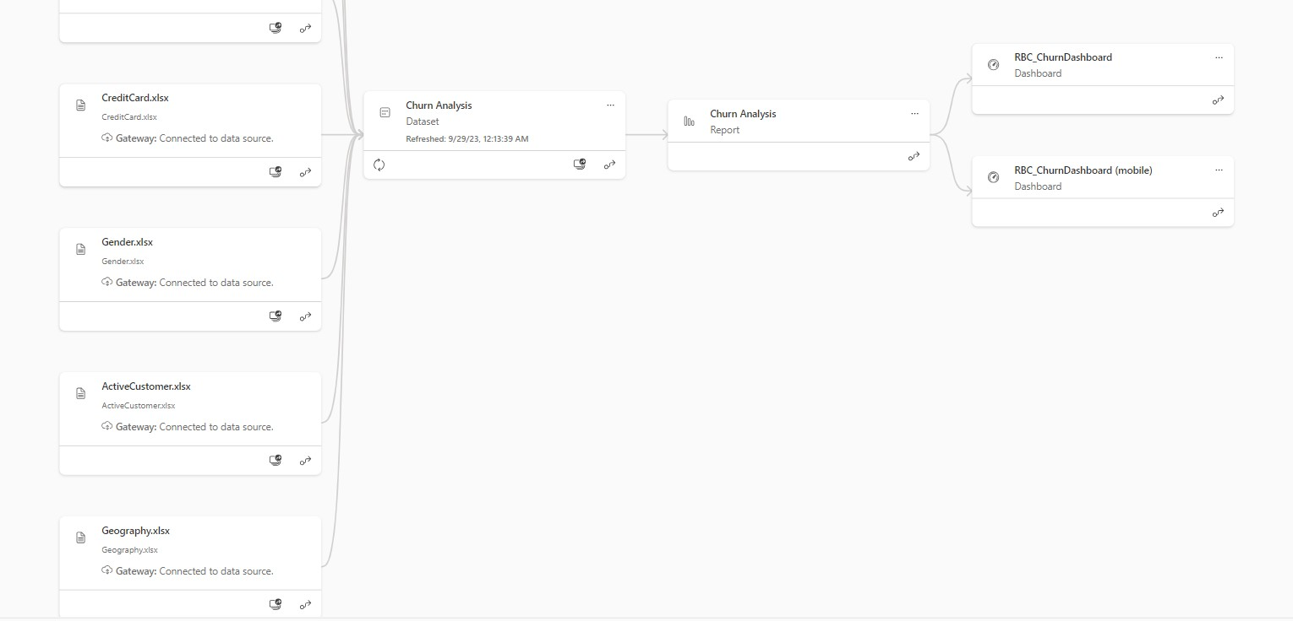

Lineage view after gateway connection

## 4.11 Schedule a refresh

Navigate back to the dataset within the workspace. Right-click to access the menu, where you'll find the option to "Schedule Refresh." Proceed to configure the refresh schedule according to your requirements. Note that for Pro accounts, there are up to 8 refreshes per day, while Premium accounts allow for up to 48 refreshes per day. Adjust the schedule based on your specific needs.

## 4.12 Add Security Roles

We already did this while dealing with creating workspace.

## 4.13 Subscription

Issue subscriptions to pertinent members and viewers to ensure they receive timely updates.

## 4.14 Manage Alerts

Already done in subpoint app creation.

## 4.15 Share the report

Distribute the app by sharing the link generated through Microsoft Power BI online. Alternatively, export the content in PDF or .ppt format to deliver a comprehensive final report to the client.

# 5. Delivering Final Report:-

We intend to present the conclusive report using a PowerPoint presentation, incorporating analytical insights and recommendations for a more impactful and visually engaging delivery.

**PresentationLink:-** [**https://docs.google.com/presentation/d/1uEeV8ydnm7hlAIS_l9qBXgDIIPcxbWOv/edit?usp=sharing&ouid=105123913650959060443&rtpof=true&sd=true**](https://docs.google.com/presentation/d/1uEeV8ydnm7hlAIS_l9qBXgDIIPcxbWOv/edit?usp=sharing&ouid=105123913650959060443&rtpof=true&sd=true)

**Presentation Video Link:-**

<https://drive.google.com/file/d/1k4SewdEgCjWoZX-FMbhMRrFLZngH9Aif/view?usp=sharing>

**Report Link:-**

<https://drive.google.com/file/d/1FUZvzxUjDjvF7lGwp0tx8S70eI7On19v/view?usp=sharing>

********